# 

| **Capstone Project Proposal:**  **Pricing Strategy Data Analysis for Wake Up! Cafe**   |  | | --- |   **Abstract:**  This capstone project aims to go through the complexities of coffee pricing by analyzing data from the coffee industry for Wake Up Café to develop a data-driven pricing strategy. |
| --- | --- |

# 

**Capstone Project Proposal: Pricing Strategy Data Analysis for Wake up! Café**

Introduction 4

Objectives 4

Problem Definition 4

Scope 7

Data Analysis Approach 7

Expected Outcomes 8

Timeline 9

References 10

# 

# 

# Capstone Project Proposal: Pricing Strategy Data Analysis for Wake up! Café

### Cafes are more than just places to grab a coffee these days; they are social hubs, productive workspaces, places of relaxation, enjoyment and sources of inspiration. They satisfy a wide range of needs, from social interaction and work to culinary experiences and mental well-being. Wake up Cafe is a people oriented business, however successful entry into this competitive market requires a strategic approach, especially in pricing.

### 

## Introduction

This capstone project aims to go through the complexities of coffee pricing by analyzing data from Wake Up Café to develop a data-driven pricing strategy. By understanding consumer behavior, market trends, and competitor pricing, we can provide valuable insights to optimize revenue and customer satisfaction. This project is significant as it addresses a real-world challenge faced by many start-up businesses: determining the optimal pricing strategy.

## Objectives

1. **Analyzing historical sales data:** To identify trends and the impact of price changes on sales volume and revenue.
2. **Conducting a competitive analysis:** To assess the pricing strategies of direct and indirect competitors in the local market.
3. **Segmenting the customer base:** To identify distinct customer segments based on their preferences, purchasing behavior, and price sensitivity.
4. **Developing a price elasticity model:** To estimate the impact of price changes on demand and revenue.
5. **Proposing a data-driven pricing strategy:** To optimize pricing based on the insights gained from the analysis, considering factors such as cost, competition, and the perception of value to customers.

## Problem Definition

As a new entrant in the coffee market, Wake Up Cafe faces the challenge of determining the optimal pricing strategy to attract customers, maximize revenue, and gain a competitive edge. The challenge is managing various factors, such as production costs, customer willingness to pay, and the competitive landscape. As a worse case scenario, a poorly executed pricing strategy can lead to reduced profitability, lost market share, and customer dissatisfaction.

**Price of Coffee**

The coffee price data consists of five locations in Ireland and the corresponding price of a cup of coffee.

The price of a cup of coffee in Ireland can vary significantly depending on the location. Rural areas generally have higher prices compared to urban centers like Dublin and Cork. Factors influencing the price are for example, the type of establishment and additional services offered, eg.: urban areas offer a wider range of options, from budget-friendly cafes to high-end coffee shops.

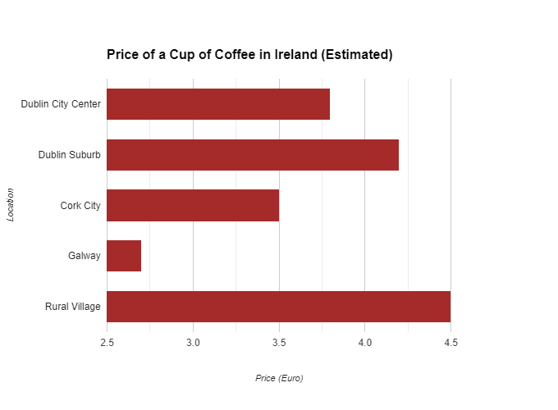

With rising costs all over: labor, raw materials, and government levies, the price of a simple cup of coffee has become a complex equation.

The factors contributing to the cost of a €4.50 brew:

**Government Taxes**

* **VAT Increase:** The recent VAT hike from 9% to 13.5% in September 2023 adds approximately 20 cents to every cup.
* **Revenue Impact:** This adds an extra €62,400 annually from our customers' pockets.

**Raw Material Costs**

* **Coffee Bean Price Increase:** The price of specialty coffee beans increased from €11.76 to €14.48 per kilogram.
* **Supply Chain Disruptions:** Post-pandemic challenges, including fuel surcharges and supply chain disruptions, have further inflated costs.
* **Quality Premium:** The demand for high-quality coffee has driven up prices, even for long-standing suppliers.

**Labor Expenses**

* **Wage Inflation:** Labor costs have risen significantly, with hourly rates increasing from €13.12 to €14.26 on average.
* **Industry Standard:** We're committed to paying above minimum wage, aligning with industry standards.

**Operational Costs**

* **Rent and Utilities:** Rising rent and utility costs, despite government relief measures, adds to hardship.
* **Marketing and Social Media:** To maintain our brand and attract customers, we need to keep at least a minimum budget for marketing and social media campaigns.
* **Financial Fees:** Bank charges, loan repayments, and insurance premiums add to overhead costs.

**Profit and Reinvestment** Our goal is to generate a modest profit to reinvest in our business, ensuring its continued growth and sustainability.

By understanding these factors, we hope to provide transparency into the pricing of our coffee. While we strive to maintain affordability, the increasing costs of doing business present significant challenges.

## Scope

This capstone project will focus on analyzing historical sales data, conducting market research, and utilizing statistical techniques to develop a comprehensive pricing strategy and it includes:

* **Data Collection and Cleaning:** Gathering and cleaning historical sales data, customer demographics, and competitor’s information.
* **Exploratory Data Analysis (EDA):** Visualizing data to identify patterns, trends, and outliers.
* **Statistical Analysis:** Employing statistical techniques like regression analysis, time series analysis, and cluster analysis to understand the relationship between price, quantity, and other factors.
* **Competitive Analysis:** Assessing the pricing strategies of direct and indirect competitors.
* **Customer Segmentation:** Identifying distinct customer segments based on their preferences, purchasing behavior, and price sensitivity.
* **Pricing Strategy Development:** Proposing a data-driven pricing strategy that balances profitability and customer satisfaction.

## 

## Data Analysis Approach

**Data Collection**

* **Historical Sales Data:**
  + Transactional data including date, time, product, quantity, and price;
  + Customer demographics (age, gender, location);
* **Market Research:**
  + Competitor’s pricing and product offerings;
  + Consumer preferences and trends in the coffee industry;
  + Economic indicators (inflation, interest rates);

**Data Cleaning and Preparation**

* **Data Cleaning:**
  + Handling missing values (imputation or removal);
  + Addressing outliers and inconsistencies;
  + Formatting data for analysis (date, time, currency);
* **Data Preparation:**
  + Aggregating data by product, time period, and customer segment;
  + Calculating relevant metrics (revenue, profit margin, customer frequency);

**Exploratory Data Analysis (EDA)**

* **Visualize Sales Trends:**
  + Time series analysis of overall sales and product-specific sales;
  + Seasonal patterns and trends;
* **Customer Segmentation:**
  + Identifying customer segments based on purchase frequency, average order value, and product preferences;
  + Analyzing the behavior of each segment;

**Statistical Modeling**

* **Demand Forecasting:**
  + Developing forecasting models to predict future demand for various coffee products;
  + Incorporating factors like seasonality, promotions, and competitor activity;
* **Price Optimization:**
  + Utilizing optimization techniques (e.g., linear programming) to determine optimal prices that maximize revenue while considering constraints like production costs and competitor pricing;
  + Conducting sensitivity analysis to assess the impact of different pricing scenarios;

## Expected Outcomes

Data-driven pricing should make recommendations for specific pricing adjustments for different coffee products and customer segments and dynamic pricing strategies to respond to market fluctuations.

Improved inventory management should be able to optimize inventory levels to reduce waste and stockouts and predict inventory planning based on demand forecasts.

And value-based pricing strategies that align with customer perceptions and loyalty programs and personalized offers to retain customers should contribute to enhanced customer satisfaction.

## Timeline

**Semester 1:**

* Data Collection, Cleaning, and Exploration

**Semester 2:**

* Statistical Analysis and Modeling
* Competitive Analysis and Customer Segmentation
* Pricing Strategy Development

### 

This two-semester capstone project offers the scope for in-depth analysis and exploration, providing actionable insights to optimize coffee prices at Wake Up Café. This will hopefully lead to increased revenue, improved customer satisfaction, and a more sustainable business model.

References:

Bhaybhang, A. (n.d.). Coffee Chains Dataset [Dataset]. Retrieved from<https://www.kaggle.com/datasets/arjunbhaybhang/coffee-chains-dataset>

Central Statistics Office (Ireland). (n.d.). PxStat Open Data Platform. Retrieved from<https://data.cso.ie/>

Faculty of Computing Level 8 HDIP Programmes 2024 - HDip in data Analytics for Business (HCI) - Sept Semester 1 StratThink_HDipData_Sept24_HCI Week 2 - Data Analytics Life Cycle, Research, Citing and Referencing Presentation [Moodle course]. Retrieved from<https://moodle.cct.ie/course>

SATSifaction. (2019, June 26). Introduction to Machine Learning with Python (Part 1) [Video file]. YouTube.<https://www.youtube.com/watch?v=_7BYZ5X57sU>

The Old Barracks (2023). The cost of a cup of coffee [Blog post]. Retrieved from<https://www.theoldbarracks.ie/blogs/news/the-cost-of-a-cup-of-coffee>